Case 6-DR Congo-Kuba-Royal Effigy-Sculpture of a King-*Ndop*-wood-late 19th c.

Note: The Democratic Republic of the Congo (DR Congo) has been known as, in chronological order, the Congo Free State, Belgian Congo, the Republic of Congo-Léopoldville, the Democratic Republic of the Congo and the Republic of Zaire, before returning to its current name the DR Congo.

Note: The Kongo people (singular: Mukongo, pl. Bakongo) speak Kikongo, a Bantu language, who have lived along the Atlantic coast of Central Africa, in a region that, by the 15th century, was a centralized and well-organized Kongo Kingdom but is now a part of three countries: DR Congo, the Republic of the Congo and Angola.

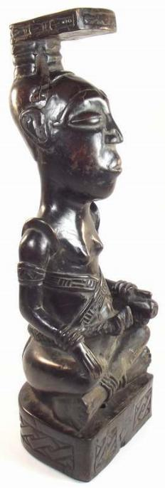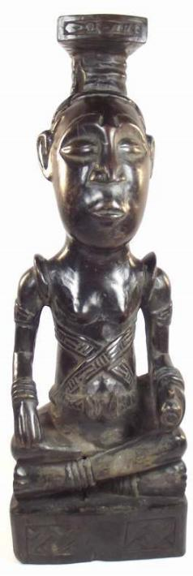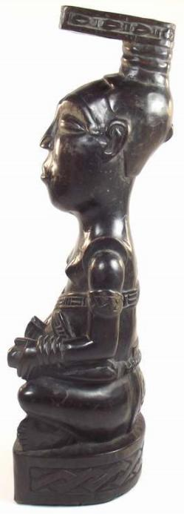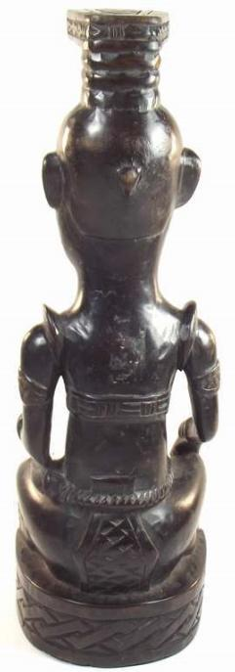

Fig. 1-4. Congo DR-Kuba-Royal Effigy-Sculpture of a King-*Ndop*-wood-late 19th c. Atlantika Collection. The short sword in his left hand held with handle out, indicates the non-aggressive posture of the *nyim*.

**Case no.: 6**

**Accession Number:**

**Formal Label:** Congo DR-Kuba-Royal Effigy-Sculpture of a King-*Ndop*-wood-late 19th c.  **Display Description:**

Kuba effigy sculpture (*Ndop*) of an actual Kuba King who was universally praised as "God on Earth," a *Nyim*, a divine ruler who controls fertility and communicates with the *Mboom*, the knowledge of natural resources channeled by the Pygmies. His demeanor expresses both aloofness and composure.

The belts, armbands, bracelets, shoulder ornaments, and special projecting headdress are all elements of royal regalia. *Ndop* figures were believed to represent and honor the spirit of the *nyim* and serve as a point of contact with his spirit.

The royal court at Nsheng is a hierarchical complex of councils and titled officials who advise the king and balance his power. Outlying Kuba chiefdoms are largely autonomous, organized on models analogous to those of the capital but on a lesser scale (Vansina 1964:98-99; 1978:216). Kuba society parallels governmental organization in that it is stratified, yet the Kuba people prize individual hard work and achievement. While one’s position of birth may secure advantage, it is not binding (Vansina 1964:188;1968:13,15).

Most Royal sculptures are modern renditions carved during a ruler’s lifetime and finally placed near the dying king to receive the royal power, which would then be transferred to his successor. The earliest examples show the workmanship of a few artists who had developed a stylistic convention that was able to serve many regents. In time these figures with carefully executed details seen in the carefully shaped headdresses and bodies that degenerated into cruder examples without fine details.

**LC Classification:** NB1099.C6

**Date or Time Horizon:** 19th c

**Geographical Area:** DR Congo

**Map:**

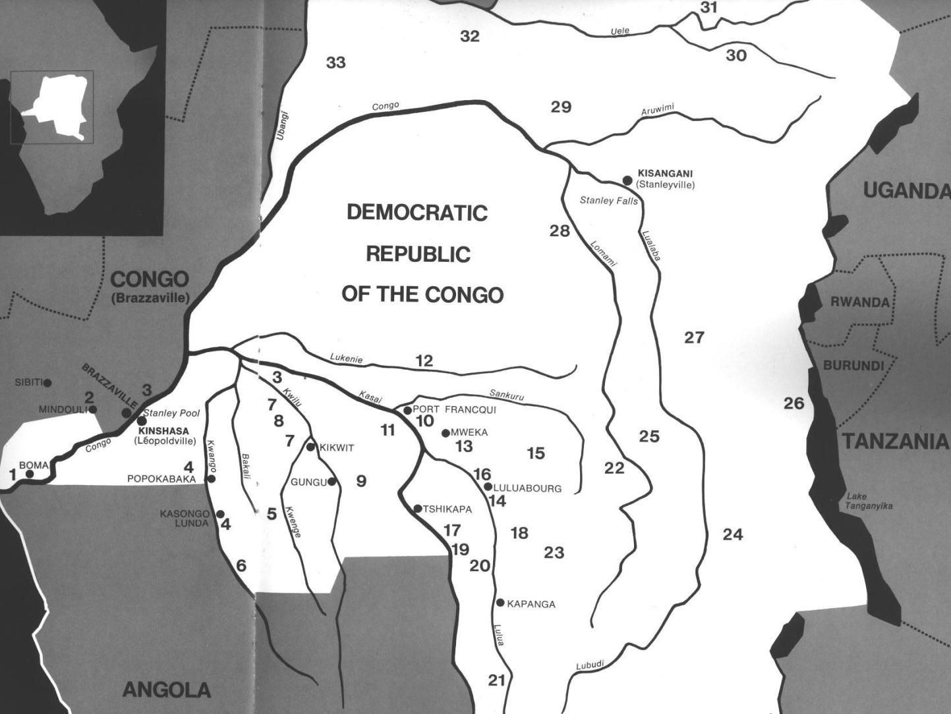

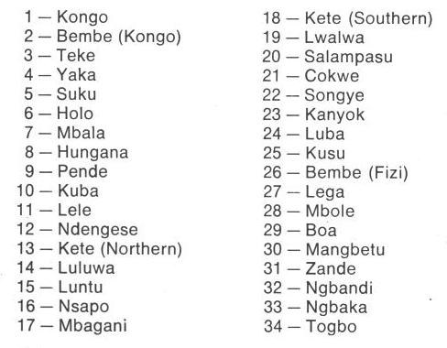

Fig. 5. Map of Kongo Cultures, West Central Africa. After Walker Art Center 1967.

**GPS coordinates:**

**Cultural Affiliation:** Kongo peoples

**Medium:** wood

**Dimensions:**

**Weight:**

**Condition: original**

**Provenance:**

**Discussion:**

In at least two impressive Royal locations the Kongo recognized the medical contributions of Pygmy lore by their own specialists: Mbanza Kongo and Loango. In order to incorporate pygmy expert medical knowledge into Kongo culture, Ntinu Lukeni married the daughter of a local pygmy spiritual leader, Manikabunga, established the town of Mpemba Kasi (near the modern village of Matadi in the Kwilu valley), where the original Kongo Kingdom rulers would be buried, and he initiated the tradition of using pygmy medicines (*bilongo*) in conjunction with the Kongo miN’kisi which therefore may have had their origins with Manikabunga.

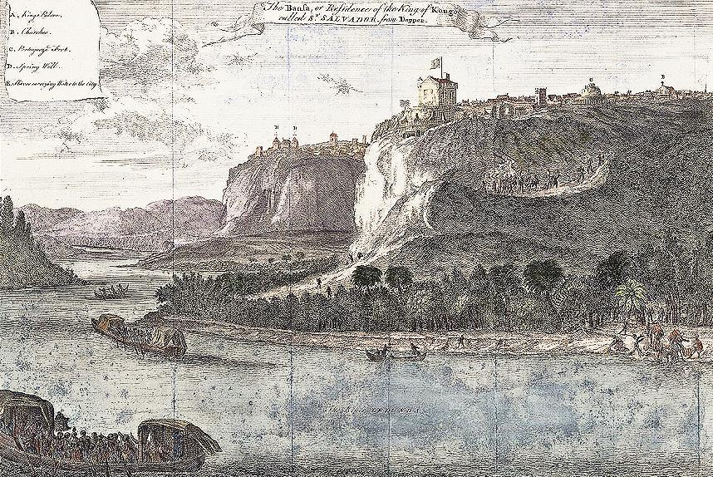

Fig. 6. Mbanza Kongo, “The Bansa or residence of the King of Kongo called Ste. Savadore [by the Portuguese] from Olfert Dapper, *Description de l’Afrique*  (Amsterdam: W. Waesberge, Boom et Van Someren, 1686), where the Kingdom’s medical specialists, *nganga* or *ngang’a n’kisi* gathered to assess and confirm local pygmy knowledge. The Nzadi or Congo River in the foreground shows two laden trade vessels.

**References:**

Adams, Monni. 1988. 8th century Kuba king figures, *African Art* 21(3): 32-38, 88.

Belepe, Bope. 1974. *Etude socio-morphologique des masques Bwoom des Kuba: Memoire de licence en histoire.* Lubumbashi: Université Nationale du Zaire.

Belepe, Bope. 1981. Les oeuvres plastiques Africaines comme documents d'histoire: Le cas des statues Royales Ndop des Kuba du Zaire, *Africa­Tervuren* 25(1): 9-17.

Binkley, D. 1987. Avatar of power: Southern Kuba masquerade figures in funerary context, *Africa* 57 (1).

Binkley, D. 1990. Masks, space and gender in southern Kuba initiation ritual, *Iowa Studies in Art.* Vol. 3, *Art and Initiation in Zaire.* Iowa City: The University of Iowa.

Brett-Smith, Sarah. 1983. “The Doyle Collection of African Art,” *Record of the Art Museum, Princeton University*, 42(2): 2+8-34.

Kuba du Zaire, Africa­ Tervuren 27(1): 9-17.

Binkley, D. 1987. Avatar of power: Southern Kuba masquerade figures in funerary context, *Africa* 57 (1).

Binkley, D. 1990. Masks, space and gender in southern Kuba initiation ritual, *Iowa Studies in Art.* Vol. 3, *Art and Initiation in Zaire.* Iowa City: The University of Iowa.

Claerhout, A. 1976. Two Kuba wrought-iron statuettes, *African Art* IX (4): 60-64.

Cornet, J. 1972. *Art de l'Afrique Noire au pays du fleuve Zaire*. Brussels: Arcade.

Cornet, J. 1975. *Art from Zaire: 100 Masterworks from the National Collection.* New York: African-American Institute.

Cornet, J. 1982. *Art royal Kuba.* Milan: Sipiel.

Ehret, Christopher. 2002. *The civilizations of Africa: a history to 1800*. Charlottesville: Virginia: University of Virginia Press.

Forbath, Peter. 1977. *The River Congo*. Boston: Houghton Mifflin.

Laman, Karl. 1953. *The Kongo*. 4. vols. Stockholm: Victor Pettersons.

MacGaffey, Wyatt. 1986. *Religion and society in central Africa: the Bakongo of Lower Zaire*. Chicago: University of Chicago Press.

MacGaffey, Wyatt. 1988. “Complexity, astonishment and power: the visual vocabulary of Kongo minkisi,” *Journal of African Studies*, (14:2), 188-203.

Martinez-Ruiz, Barbaro. 2013. *Kongo Graphic Writing and other Narratives of the Sign*. Philadelphia: Temple University Press.

Rosenwald, J. B. 1974. “Kuba king figure,” *African Art,* VII (3).

Schadeberg, Thilo. 1999. “Batwa: the Bantu name for the invisible people.” In *Challenging Elusiveness: Central-African Hunter Gatherers in a Multidisciplinary perspective*, ed. K. Beibrouck, S. Elders, and G. Rossel. Leiden: CNWS, 21-39.

Thompson, Robert Farris. 1978. “The Grand Detroit N’kondi,” *Bulletin of the Detroit Institute of Arts* 56 :4, 206-217.

Torday, E. and T. A. Joyce. 1911. « Notes ethno­graphiques sur les peuples communement appeles Bakuba, ainsi que sur les peuplades apparentees, les Bushoongo. » In *Annales du Musee Royal du Congo Belge, Ethnographie et Anthropologic.,* serie III, tome II, fasc. 1. Brussels: Tervuren.

Vansina, Jan. 1955 “Initiation Rituals of the Bushong,” *Africa* 25(2): 138-153.

Vansina, Jan. 1964. *Le royaume kuba.* Tervuren: Musée royal de l'Afrique centrale.

Vansina, Jan. 1978. *The children of Woot. A history of the Kuba peoples.* Madison: University of Wisconsin Press/Dawson.

Vansina, Jan. 1984. *Art History in Africa.* London: Longman.

Van Wing, Joseph Hubert Leopold. 1941. *Études Bakongo*. II. *Religion et magie*. Institut royal colonial belge. Section des sciences morales et politiques. Mémoires, collection in-8°, t. IX, fasc. 1. Brussels: Desclée de Brouwer.

Van Wing, Joseph Hubert Leopold. 1959. *Études Bakongo.* Brussels: Desclée de Brouwer.

Walker Art Center. 1967. *Art of the Congo*. Minneapolis: Walker Art Center.